LMS Online Quiz – Quiz Overrides

Dates, timing and number of allowed attempts may be changed for individual users or groups by following the links Group Overrides or User Overrides in Quiz administration. In situations where two group overrides may apply to a single user, the most lenient date is used. For "Open the quiz" dates, this means the earliest possible date is used, for "Close the quiz" dates, this means that the latest possible date is used Note also that if there exists a user override for a student, it will always take precedence over any group overrides.
Group overrides
To change a quiz setting for a particular group, click the "add group override" button in Quiz Actions Menu>Group overrides, make the changes you wish and save or enter another override.
User overrides
To change a quiz setting for a particular user or users, click the "add user override"button in Quiz Actions Menu>User overrides, make the changes you wish and save or enter another override.

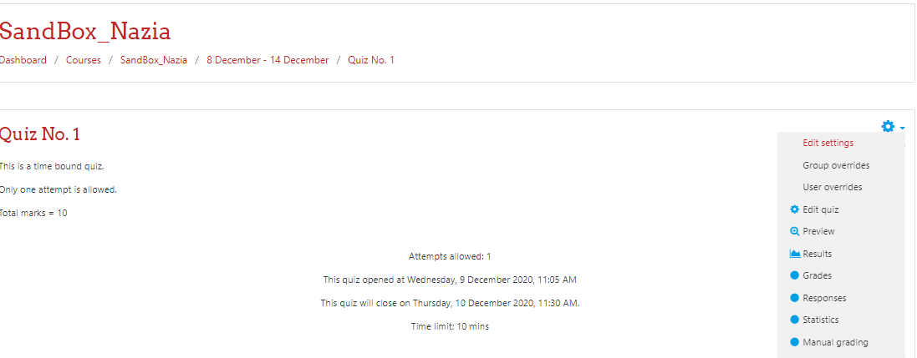

Click on the button “Add user override” to extend quiz date, time or attempts for a specific user.

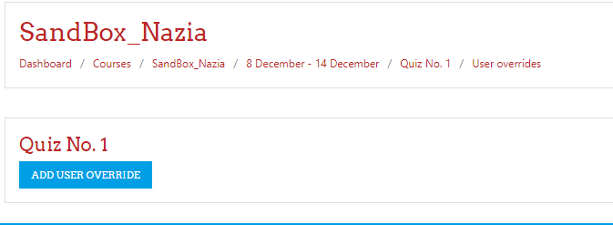

Search the user for whom you want to override the quiz settings from the list of students.

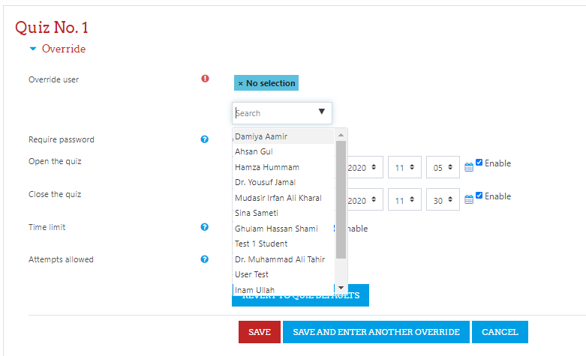

You can extend quiz open/ close time, the quiz time limit and number of attempts for the selected user. Save the settings.
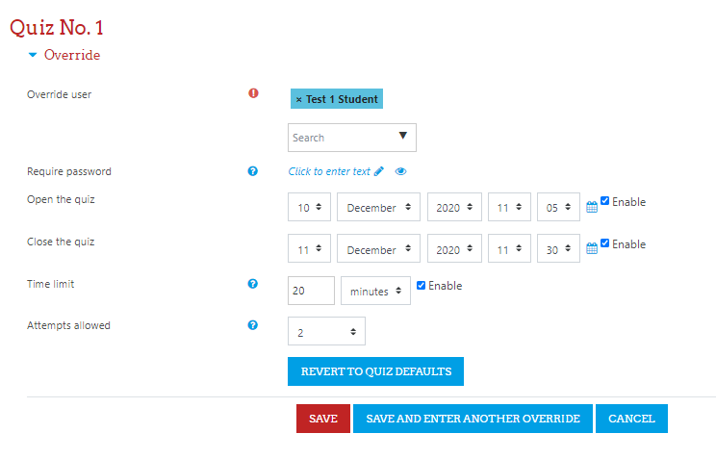
All the overridden settings will be displayed with the student name. Using the delete icon in the Action column, the overridden conditions can be deleted by the teacher.





